Colonial Hills
Play Group Schedule
Jan. – May 2013
_______________________________________________________________

January 19
Sat. 1:45 p.m.

Paradise Park – Children’s Edutainment Center

Water play, ball pit, blocks, cooking, art, face painting, toddler activities, games, dress up with pretend bank, house, store, medical room and more! Invite your friends and join the fun! (For ages birth to 9)

Check out the video: http://www.paradise-park.com/childrensedutainment.aspx

We will meet at Paradise Park in Lee’s Summit at 1:45 p.m.
At 2 p.m. Adventure Time begins with special activities at each station. You may stay as long as you’d like… Center closes at 9:00 p.m.

1021 NE Colbern Rd.
Lee's Summit, MO 64086
Ph: 816.246.5224

Child (2-9 years old) $9.00
Child (Under 2 years old) $4.50
Child (Under 1 year old) Free!
Adult Admission $3.00

______________________________________________________________

February 9
Sat. 5 – 8 p.m.

Kid's Night Out (& Date night for Parents)

Dinner, crafts, music, and games… your child is sure to enjoy this fun Kid’s Night Out at Colonial Hills. Timely, too, for parents to go out on the town with their Valentine.

Middle School and High School youth are planning and supervising this event as a fundraiser for their Mission Trip to Belize. Please RSVP by Feb. 1.

Colonial Hills Community of Christ
3539 S 7 Hwy Blue Springs, MO

Cost is $10.00 per child ages 3 to 10 (includes dinner and craft materials)
Cost for children under 2 is $5.00 Of course all TIPS are welcome for this youth group fundraiser!

_______________________________________________________________

March 9
Sat. 1:30 – 3:00 p.m.

Children's Peace Pavilion

Let’s help our kids learn about peace! This free hands-on museum will delight every child… with art, puppets, music and play. Friends are welcome!

We will meet at the west doors of the Community of Christ Auditorium.

1001 W. Walnut, Independence, MO 64050-3562
816-521-3033
http://www.cofc3.org/kidpeace/default.asp

_______________________________________________________________

March 23
Sat. 9 to Noon

Colonial Hills Easter Eggstravaganza!
Free Pancake Breakfast!
Photos with the Easter Bunny ($1.00 or bring your own camera)
Egg Hunt All Morning (Rain or Shine)
Games, Crafts, and Face Painting!
Prize Drawings!

Invite your friends and family!

_______________________________________________________________

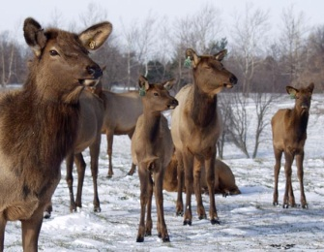
April 27
Sat., 10:00 a.m.

Native Hooved Animal Enclosure –
Feeding Elk and Bison

Bring long carrots, apples or pears and feed the elk and bison enclosed at Fleming Park.
Meet at 10:00 a.m. Stay as long as you’d like. Remember to invite your friends!

Directions from Colonial Hills… Drive south on 7 Hwy. Turn right on Cowherd Rd, at the T take a right on E Park Rd. Pull off is on the right.

Learn fun fact about elk: http://www.jacksongov.org/content/7894/7922/7962/default.aspx

_______________________________________________________________

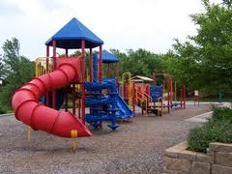
May 18
Sat., 11:00 a.m.

Picnic & Play at Rotary Park/Railroad Lake
Bring your picnic lunch and join us for an enjoyable day with your family! Friends are welcome!
600 Northwest Vesper Street
Blue Springs, MO 64014

Additional amenities: http://www.bluespringsgov.com/index.aspx?NID=484

More fun to come this summer!!

